**CHAPTER 1**

# INTRODUCTION

## 1.1 OVERVIEW OF THE PROJECT

This report explains all the details of development process for the **Location tracking of an Android device using SMS** software system.

The main feature of **Location tracking when Calling** is to provide location tracking functionalities to Android devices using SMS. This application locates device by making device ring and get latitude and longitude of an Android device. Also the **Location tracking when Calling** have the capability of authentication to share the location information with the sender of SMS.

The Android application gives the opportunity to share location information with the users through SMS. In order to do that, the application receives each SMS, matches contents of SMS with predefined attention word. If attention word matches with the predefined word than application makes device ringing or get location details of device and acknowledges the user through SMS.

**MOTIVATION**

As a result of technological progress we are facing an incredible variety of possibilities to communicate regardless of the distance. Smart phones provide a great choice of features that facilitate the life for the users as well they make it more comfortable.

Every day the features and capabilities of Mobiles are increasing surprisingly. For this reason we want to create an Android application which gives us the opportunity to improve our knowledge of Mobile developing. We find this project a great opportunity to combine a lot of technologies and languages in the same software system, and learn how to work in big projects as a team member. An important motivation for us is the challenge to solve all the problems that will arise while the project is developed. In addition, we will try to make the program portable, reliable, secure, stable, intuitive, etc.

## 1.2 PROBLEM STATEMENT

A silent phone can be extremely tricky to find. If you're in the habit of losing a silent cell phone, you may wish to invest in a phone sensor, also known as a phone detector. The user has to follow tedious procedures to find his theft phone and ultimately user may not find his phone. This procedure is time consuming too.

## 1.3 PROJECT DESCRIPTION

### Objective:

The objective of this project is to provide location tracking functionalities to Android devices using SMS. This application locates device by making device ring and get latitude and longitude of an Android device.

### Purpose:

If an android user wants to know the location of Android device then user has to send SMS to designated device. So that he can locate device either by it making ring or gets actual location of device using GPS or network provider.

### Scope:

This project supports only the Android OS and makes communication with the tracker through SMS messages only. The Architecture, Security and the accuracy of tracking unit itself are the scope of this project.

This single application consists of modules like

* Ringer
* Location tracking

**CHAPTER 2**

# LITERATURE SURVEY

## 2.1 EXISTING SYSTEM

**Ringer**

A silent phone can be extremely tricky to find. If you're in the habit of losing a silent cell phone, you may wish to invest in a phone sensor, also known as a phone detector. These are tools that, when placed near a cell phone, will actually pick up the call signal and make sounds to indicate that the phone is somewhere within proximity. If the phone is lost, all you need to do is have someone call you as you walk around with the sensor until the device begins to indicate that a call signal is nearby. When you hear the signal, you then have a basic idea of where to start looking for your cell phone.

**Phone Tracking Using IMEI Number:**

Every phone comes with a unique International Mobile Equipment Identify Number which can come in useful to track it in case of loss or theft. This number can be accessed by dialing *#06# and it is advisable to make a note of it as soon as you purchase your handset. In case the phone gets stolen, file an FIR with the police and give them its identity number.

Pass on a copy of the FIR and IMEI number to your service provider who will then be able to track your handset. With its IMEI number, a device can be traced even if it is being used with another SIM or even if it is switched off. Once the handset is located, request your service provider to block it from being used till you are able to get your hands on it again.

## 2.2 PROPOSED SYSTEM

**Ringer**

Using simple SMS commands you can ring your Android Device even though it is in silent mode and thus locate your device locally.

**Location Tracking**

In this proposed system you can locate any phone that has been misplaced or stolen. Once the App is installed on the phone, it can be located by sending SMS with predefined keyword. The system gets you current updated location.

## **2.3 SOFTWARE DEVELOPMENT TOOL**

### 2.3.1 Introduction to Java

Java is a programming language created by James Gosling from Sun Microsystems (Sun) in 1991. The first publicly available version of Java (Java 1.0) was released in 1995. Sun Microsystems was acquired by the Oracle Corporation in 2010. Over time new enhanced versions of Java have been released. The current version of Java is Java 1.7 which is also known as Java 7. From the Java programming language the Java platform evolved. The Java platform allows software developers to write program code in other languages than the Java programming language and still runs on the Java virtual machine. The Java platform is usually associated with the Java virtual machine and the Java core libraries.

**Java Virtual machine**

The Java virtual machine (JVM) is a software implementation of a computer that executes programs like a real machine. The Java virtual machine is written specifically for a specific operating system, e.g. for Linux a special implementation is required as well as for Windows.

**Java Runtime Environment vs. Java Development Kit**

A Java distribution comes typically in two flavors, the Java Runtime Environment (JRE) and the Java Development Kit (JDK).The Java runtime environment (JRE) consists of the JVM and the Java class libraries and contains the necessary functionality to start Java programs. The JDK contains in addition the development tools necessary to create Java programs. The JDK consists therefore of a Java compiler, the Java virtual machine, and the Java class libraries.

**Characteristics of Java**

The target of Java is to write a program once and then run this program on multiple operating systems.

Java has the following properties:

**Platform independent:** Java programs use the Java virtual machine as abstraction and do not access the operating system directly. This makes Java programs highly portable. A Java program (which is standard complaint and follows certain rules) can run unmodified on all supported platforms, e.g. Windows or Linux.

**Object-orientated programming language:** Except the primitive data types, all elements in Java are objects.

**Strongly-typed programming language:** Java is strongly-typed, e.g. the types of the used variables must be pre-defined and conversion to other objects is relatively strict, e.g. must be done in most cases by the programmer.

**Interpreted and compiled language:** Java source code is transferred into the byte code format which does not depend on the target platform. These byte code instructions will be interpreted by the Java Virtual machine (JVM). The JVM contains a so called Hotspot-Compiler which translates performance critical byte code instructions into native code instructions.

**Automatic memory management:** Java manages the memory allocation and de-allocation for creating new objects. The program does not have direct access to the memory. The so-called garbage collector deletes automatically objects to which no active pointer exists.

**2.3.2 Android**

Android is a software platform and operating system for mobile devices. Android is available as open source. It allows developers to write managed code in the Java language, controlling the device via Google-developed Java libraries.

Android SDK was released by Open Handset Alliance in the month of November of the year 2007. Android is actually developed using the kernel of Linux 2.6 and the highlighting features of Android include the following [7]:

• No fees for licensing, distribution and release approval

• GSM, 3G EDGE networks for telephony

• IPC message passing

• Background processes and applications

• Shared data stores

• Complete multimedia hardware control

• API’s for location based services such as GPS.

**2.3.2.1 Architecture of Android OS**

The skeleton of Android framework and its constituents are shown in the following figure:

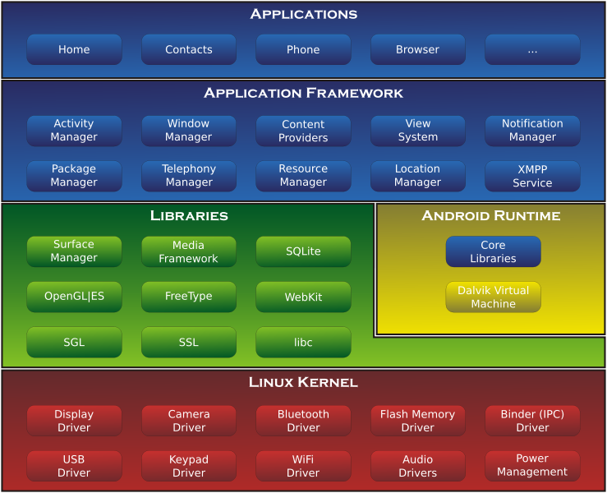

**Figure 2.1: Architecture of Android OS**

**Applications Layer**

Android ships with a set of core applications including an email client, SMS program, calendar, maps, browser, contacts and others. All applications are built using the Java. Each of the application aims at performing a specific task that it is actually intended to do.

**Application Framework Layer**

The next layer is the application framework. This includes the programs that manage the phone’s basic functions like resource allocation, telephone applications, switching between processes or programs and keeping track of the phone's physical location. Application developers have full access to Android's application framework. This allows them to take advantage of Android's processing capabilities and support features when building an Android application. We can think of the application framework as a set of basic tools with which a developer can build much more complex tools.

**Libraries Layer**

The next layer contains the native libraries of Android. These shared libraries are all written in C or C++, compiled for the particular hardware architecture used by the phone and preinstalled by the phone vendor.

**Android Runtime Layer**

Android Runtime layer includes Dalvik Virtual Machine (DVM) and a set of core java libraries.

Every Android app gets its own instance of DVM. Dalvik has been written so that a device can run multiple virtual machines efficiently and it executes files with .dex (Dalvik Executable Format) extension optimized for minimum memory.

**2.3.2.2 Components of Android**

The basic components of an Android application include Activity, Broadcast Receiver, Service, and Content Provider. Each of these which when used forany application has to be declared in the AndroidManifest.xml. The user interface of the component is determined by the Views. For the communication among these basic components we use Intents and Intent filters which play crucial role during app development.

**Figure 2.2: Structure of Android Components**

**Activity**

An Activity is, fundamentally, an object that has a lifecycle. An Activity is a chunk of code that does some work; if necessary, that work can include displaying a UI to the user. It doesn't have to, though-some Activities never display UIs. Typically, we will designate one of our application's Activities as the entry point to our application.

**Broadcast Receiver**

Broadcast Receiver is yet another type of componentthat can receive and respond to any broadcast announcements.

**Service**

A Service is a body of code that runs in the background. It can run in its own process, or in the context of another application's process, dependingon its needs. Other components "bind" to a Service and invoke methods on it via remote procedure calls. An example of a Service is a media player; even when the user quits the media-selection UI, she probably still intends for her music to keep playing. A Service keeps the music going even when the UI has completed.

**Content Provider**

Content Provider is a data storehouse that providesaccess to data on the device; the classic example is the Content Provider that's used to access the user's list of contacts. Our application can access data that other applications have exposed via a Content Provider, and we can also define our own Content Providers to expose data of our own.

**2.3.2.3 Location based Services in Android**

Android's Network Location Provider determines user location using cell tower and Wi-Fi signals, providing location information in a way that works indoor and outdoor, responds faster, and uses less battery power. The purpose of location-based services is to find the Physical location of the device. Access to the location-based services is handled by the LocationManager system Service. To access the Location Manager, request an instance of the LOCATION_SERVICE using the get System Service() method. Current Location can be fetched using two ways:

1. GPS (Global Positioning System)

2. Network Service Location

**GPS (Global Positioning System)**

The Global Positioning System (GPS) uses a constellation of 24 satellites orbiting the earth. GPS finds the user position by calculating differences in the times the signals, from different satellites, take to reach the receiver. GPS signals are decoded, so the smart phone must have in-built GPS receiver. To get access to GPS hardware of android we request using following statement **LocationManager.GPS_PROVIDER;**



**Figure 2.3: Architecture of A-GPS System**

**Network Service Location**

The current cell ID is used to locate the Base Transceiver Station (BTS) that the mobile phone is interacting with and the location of that BTS. It is the most basic and cheapest method for this purpose as it uses the location of the radio base station that the cell phone is connected to. A GSM cell may be anywhere from 2 to 20 kilometers in diameter. Other approaches used along with cell ID can achieve location granularity within 150 meters. The granularity of location information is poor due to Wide Cell Range. The advantage is that no additional cost is attached to the handset or to the network to enable this service.

To get access to Network Provider android we request using following statement **LocationManager.NETWORK_PROVIDER;**

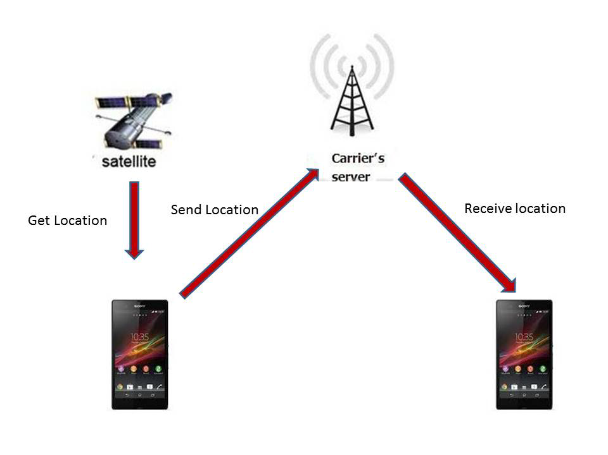

**Geocoding and Reverse Geocoding**

Geocoding lets us translate between street addresses and longitude/latitude map coordinates. This can give us a recognizable context for the locations and coordinates used in location-based services and map-based activities. The Geocoding lookups are done on the server, so our applications will require us to include an Internet uses-permission in our manifest. The Geocoder class provides access to two geocoding functions:

• Forward Geocoding

Forward Geocoding converts the address into latitude and longitude.

• Reverse Geocoding

Reverse Geocoding converts latitude and longitude to corresponding address

**2.3.3 Eclipse**

**Eclipse** is a multi-language [software development environment](http://en.wikipedia.org/wiki/Software_development_environment) comprising an [integrated development environment](http://en.wikipedia.org/wiki/Integrated_development_environment) (IDE) and an extensible [plug-in](http://en.wikipedia.org/wiki/Plug-in_%28computing%29) system. It can be used to develop applications in Java and, by means of various plug-ins, other [programming languages](http://en.wikipedia.org/wiki/Programming_language) like c, c++, android etc….

Features

1. It is an open source.
2. It is strongly recommended by Android developer.
3. It is directly linked with compiler, so we don’t need to compile the program
4. It has good UI(user interface)

CHAPTER 3

# SOFTWARE DEVELOPMENT LIFE CYCLE

## 3.1 V-MODEL

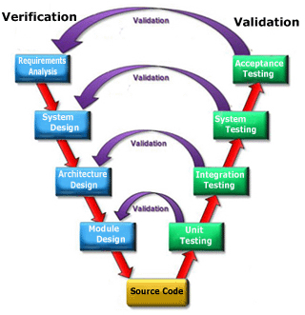

**Fig 3.1: V-Model**

The **V-model** represents a software development process (also applicable to hardware development) which may be considered an extension of the waterfall model. Instead of moving down in a linear way, the process steps are bent upwards after the coding phase, to form the typical V shape. The V-Model demonstrates the relationships between each phase of the development life cycle and its associated phase of testing. The horizontal and vertical axes represents time or project completeness (left-to-right) and level of abstraction (coarsest-grain abstraction uppermost), respectively.

### Verification Phases

**Requirements Analysis**

The user requirements document will typically describe the system’s functional, interface, performance, data, security, etc. requirements as expected by the user. It is used by business analysts to communicate their understanding of the system to the users. The users carefully review this document as this document would serve as the guideline for the system designers in the system design phase.

### System Design

Systems design is the phase where system engineers analyze and understand the business of the proposed system by studying the user requirements document. They figure out possibilities and techniques by which the user requirements can be implemented. If any of the requirements are not feasible, the user is informed of the issue. A resolution is found and the user requirement document is edited accordingly.

**Architecture Design**

The phase of the design of computer architecture and software architecture can also be referred to as high-level design. The baseline in selecting the architecture is that it should realize all which typically consists of the list of modules, brief functionality of each module, their interface relationships, dependencies, database tables, architecture diagrams, technology details etc. The integration testing design is carried out in the particular phase.

**Module Design**

The module design phase can also be referred to as low-level design. The designed system is broken up into smaller units or modules and each of them is explained so that the programmer can start coding directly. The low level design document or program specifications will contain a detailed functional logic of the module, in pseudo code:

* Database tables, with all elements, including their type and size.
* All interface details with complete API references.
* All dependency issues.
* Error message listings.
* Complete input and outputs for a module.

### Validation Phases

**Unit testing**

Try to detect if all application functions work correct individually.

**Integration testing**

Try to detect if all these functions are accessible in our application and they are properly integrated.

**System Testing**

System testing checks if the integrated product meets the specified requirements.

**Acceptance Testing**

Acceptance testing is the phase of testing used to determine whether a system satisfies the requirements specified in the requirements analysis phase. The acceptance test design is derived from the requirements document. The acceptance test phase is the phase used by the customer to determine whether to accept the system or not.

CHAPTER 4

# SOFTWARE REQUIREMENT SPECIFICATION

## 4.1 INTRODUCTION

Software Requirement Specification (SRS) is the starting point of the software development activity. It is a complete description of the behavior of a system which is to be developed. The SRS document enlists all necessary requirements for project development. To derive the requirements we need to have clear and thorough understanding of the product which is to be developed. This is prepared after detailed communication with project team and the customer.

A SRS is a comprehensive description of the intended purpose and environment for software under development. The SRS fully describes what the software will do and how it will be expected to perform.

An SRS minimizes the time and effort required by developers to achieve desired goals and also minimizes the development cost. A good SRS defines how an application will interact with system hardware, other programs and human users in a wide variety of real-world situations.

**Characteristics of SRS:**

* **Correct** - An SRS is correct if, and only if, every requirement stated therein is one that the software shall meet. Traceability makes this procedure easier and less prone to error.
* **Unambiguous** - An SRS is unambiguous if, and only if, every requirement stated therein has only one interpretation. As a minimum, this requires that each characteristic of the final product be described using a single unique term.
* **Verifiable** – It is verifiable if there exists some finite cost-effective process with which a person or machine check whether software product meets requirements.
* **Consistent** - Consistency refers to internal consistency. If an SRS does not agree with some higher-level document, such as a system requirements specification, then it is not correct. An SRS is internally consistent if, and only if, no subset of individual requirements described in it conflict.
* **Modifiable** – SRS is said to be modifiable if its structure and style are such that any changes to the requirements can be made easily, completely and consistently while retaining the structure and style.
* **Traceable** – SRS is said to be traceable if the origin of each of its requirements is clear and it facilitates the referencing of each requirement in future enhancement.
* **Ranked for importance or stability** – SRS is ranked for importance or stability if each requirement in it has an identifier to indicate either the importance or stability of that particular requirement.

## 4.2 FUNCTIONAL REQUIREMENTS

## Modules: This application contains two important modules.

## Ringer

## Location Tracker

### Ringer

* Be able to recognize the attention word received through SMS.
* Be able to handle the phone state to ring automatically.
* Be able to send phone state through SMS.

### Location Tracking

* Be able to detect the current location of Android device.
* Be able to retrieve the device, SIM card & location details.
* Be able to send retrieved details through SMS.

## 4.3 NON FUNCTIONAL REQUIREMENTS

#### Performance Requirements:

Application must respond within 5 seconds excluding GPS enabling time. The user must use the required option to get the information of the users.

**Reliability:**

This application has various other features like SMS this can be extensible with many features in the user devices.

**Availability:**

This proposed system find extended application who are installed this application those users can be get the location of the device and send the details back to requesting phone.

**Maintainability:**

Since we are using JAVA software to support our application no maintenance is very easy and economical also.

**Portability:**

The project is built using JAVA and can be run on any device which uses android OS.

**Safety Requirements:**

It is better to use the antivirus and keep on checking for the latest updates of the application.

**Security Requirements:**

The application will prompt the user for upgrading and downloading new features updated by the developer.

## 4.4 SYSTEM REQUIREMENTS

### HARDWARE REQUIREMENTS

**On Developer Side**

Processor : Dual core or above.

RAM : 4GB.

Hard disk : 40GB or above.

Monitor : 15’’ LCD or CRT Monitor or above.

Keyboard : Standard windows keyboard

**On Client Side**

Device : GPS enabled Android OS mobile.

### SOFTWARE REQUIREMENTS

Development Kit: Android SDK 2.3, Java JDK 1.6.

Languages : Java.

IDE : Eclipse Helios, Android Emulator.

Platform : Window 7/XP.

## 4.5 USE CASE DIAGRAM

A use case is a coherent piece of functionality that a system provides interacting with actors. It describes a system which involves a set of use cases and a set of actors.A use case diagram summarizes who uses our application or system and what they can do with it.

By use case diagram we can achieve,

* The scenario in which our application interacts with people, organizations or external systems.
* The goals that it helps those actors to achieve.
* The scope of our system.

The components included in it are as follows:

* **Actor** - Actors represent classes of users, organizations, and external systems that interact with your system.
* **Use Cases** - Use cases represent the activities that actors perform with the help of your system.

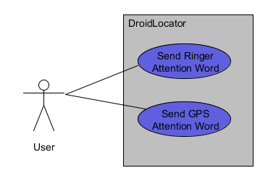

**Fig 4.1 Use Case Diagram**

CHAPTER 5

# SYSTEM DESIGN

System design is the solution to the creation of a new system. This phase is composed of several systems. This phase focuses on the detailed implementation of the feasible system. It emphasis on translating design specifications to performance specification is system design. System design has two phases of development logical and physical design.

During logical design phase the analyst describes inputs (sources), outputs (destinations), databases (data stores) and procedures (data flows) all in a format that meats the uses requirements. The analyst also specifies the user needs and at a level that virtually determines the information flow into and out of the system and the data resources. Here the logical design is done through data flow diagrams and database design.

The physical design is followed by physical design or coding. Physical design produces the working system by defining the design specifications, which tell the programmers exactly what the candidate system must do.

The programmers write the necessary programs that accept input from the user, perform necessary processing on accepted data through call and produce the required report on a hard copy or display it on the screen.

## 5.1 SYSTEM ARCHITECTURE

### Architectural Design:

3-Tier architecture is also called layered architecture. Some people called it n-tier architecture. Layer architectures are essentially objects and work in object oriented environment. 3-tier architecture is a very well-known architecture in the world of software development, it doesn't matter whether you are developing web based application or desktop based, it is the best architecture to use.

3-Tier architecture consists of1) UI or Presentation Layer  
2) Business Access Layer or Business Logic Layer  
3) Data Access Layer

**Presentation Layer:**  
Presentation layer consists of pages like .java or desktop based form where data is presentedtousersorgettinginputfrom users.

**BusinessLogiclayerorBusinessAccessLayer**

Business logic layer contains all of the business logic. Its responsibility is to validate the business rules of the component and communicating with the Data Access Layer. Business Logic Layer is the class in which we write functions that get data from Presentation Layer and send that data to database through Data Access Layer.

**Data Access Layer:**

Data Access Layer is also the class that contains methods to enable business logic layer to connect the data and perform desired actions. These desired actions can be selecting, inserting, updating and deleting the data. DAL accepts the data from BAL and sends it to the database or DAL gets the data from the database and sends it to the business layer. In short, its responsibility is to communicate with the backend structure.

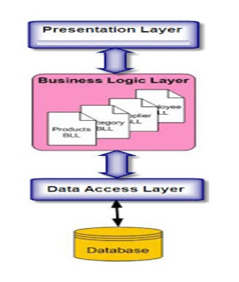

**Fig 5.1: Illustration of3-Tier Architecture with Diagram.**

## 5.2 UML DIAGRAMS

### 5.2.1 State Machine Diagram

A State diagram is a graph whose nodes are states and whose directed arcs are transitions between the states. It specifies the state sequences caused by event sequences. State names must be unique within the scope of the diagram. State diagrams are used to give an abstract description of the behavior of a system. This behavior is analyzed and represented in series of events that could occur in one or more possible states.

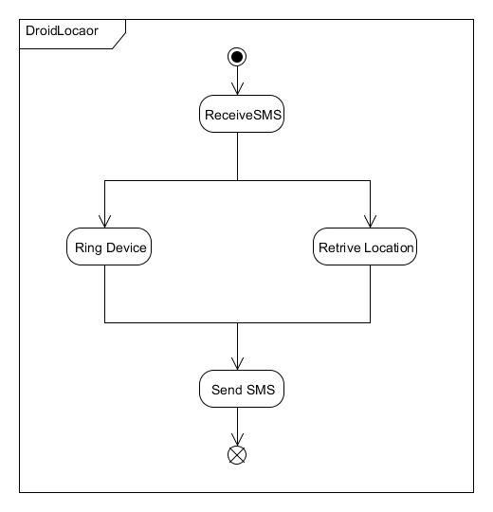

**Fig 4.2: State Diagram**

### 5.2.2 Activity Diagram

Activity Diagram shows the sequence of steps that make up complex process. It shows the flow of control, similar to sequence but focuses on operation rather than on objects.

The components used in this are as follows:

* **Rounded Rectangle** – It indicates the process.
* **Arrow** – It indicates transition line.
* **Rhombus**  – It indicates the decision.
* **Bars** – It represents the start or end of concurrent activities.
* **Solid Circle** – It represents the initial state of workflow.
* **Encircled Black Circle** –It represents the final state of workflow.

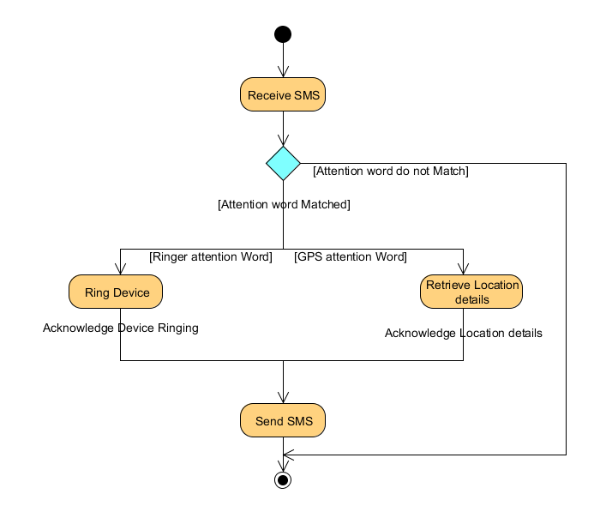

**Fig 5.2 Activity Diagram**

### 5.2.3 Sequence Diagram

A Sequence diagram shows how a set of objects communicate with each other to perform a complex task. This type of diagram allows the other developer to verify that the interaction is correct.

A Sequence diagram shows, as parallel **vertical lines (lifelines),** different processes or objects that live simultaneously, and as **horizontal arrows**, the messages exchanged between them, in the order in which they occur. This allows the specification of simple runtime scenarios in a graphical manner.

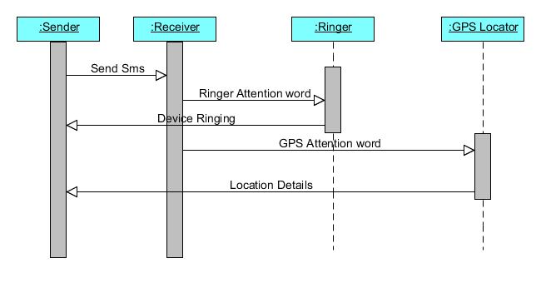

**Fig 5.3 Sequence Diagram**

### 5.2.3 Class Diagram

In software engineering, a **class diagram** in the Unified Modeling Language (UML) is a type of static structure diagram that describes the structure of a system by showing the system's classes, their attributes, operations (or methods), and the relationships among objects.

In the diagram, classes are represented with boxes which contain three parts:

* The top part contains the name of the class
* The middle part contains the attributes of the class
* The bottom part gives the methods or operations the class can take or undertake

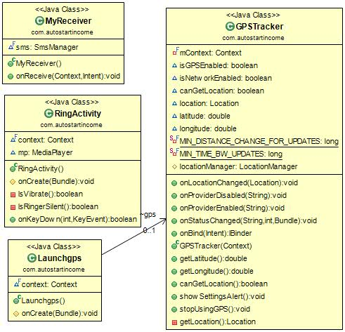

**Fig 5.4 Class Diagram**

CHAPTER6

# IMPLEMENTATION

## 6.1 INTRODUCTION:

After designing the new system, the whole system is required to be converted into computer understanding language. Codingthe new system into computer programming language does this. It is an important stage where the defined procedures are transformed into control specifications by the help of a computer language. This is also called the programming phase in which the programmer converts the program specifications into computer instructions, which we refer as programs. The programs coordinate the data movements and control the entire process in a system.

It is generally felt that the programs must be modular in nature. This helps in fast development, maintenance and future change, if required.

The validity and proper functionality of all the modules of the developed application is assured during the process of implementation. Implementation is the process of assuring that the information system is operational and then allowing user to take over its operation for use and evaluation.

Implementation is the stage in the project where the theoretical design is turned into a working system. The implementation phase constructs, installs and operated the new system. The most crucial stage in achieving a new successful system is that it works effectively and efficiently.

## 6.2 MODULES

1. Send attention word text:
   * + *Perform predefined action according to alert word and abort broadcasting.*
2. Send text other than attention word:
   * + *Allow broadcasting*
3. Make device ring.
4. Acknowledges device ringing status to the user by sending SMS.
5. Get latitude and longitude of device and create a Google map link.
6. Send device location to sender of SMS.
7. Exit Application

## 6.2.1 IMPLEMENTATION OF MODULES

## 6.2.1.1 Broadcast receiver that alerts application when each new SMS arrived.

This module decides which action has to perform when attention word matches with the keyword “ringmydevice”. If it is matched then it starts activity which enables device ringing. If attention word matches with the keyword “getlocation” then it starts activity which retrieves location of device and sends information to the sender of SMS. At the same time it aborts message broadcasting so that message can’t be reached to inbox of native messaging application.

If attention word is not matched with the specified key word than it simply allow broadcasting so that message can be reached to inbox of native messaging application.

**Step 1:** START

**Step 2:**SMS received.

**Step 3:**Checks attention word.

**Step 4:**If attention word matches with “ringmydevice” then starts ringing activity and abort broadcasting.

**Step 5:**If attention word matches with “getlocation” then starts ringing activity and abort broadcasting.

**Step 6:** If attention word not matched then allow broadcasting.

**Step 7:**End

### 

### 6.2.1.2 Enable device ringing and acknowledges the user.

Received attention word text is “ringmydevice”:

In this module we provide the functionality of making device ringing by sending an attention word to android device. **DroidLocator** recognizes the keyword “**ringmydevice**” and makes device ringing no matter it is in silent or vibrate mode. So user can locate his phone.

**Step 1:** START

**Step 2:**Checks device it in silent or vibrate mode.

**Step 3:**If it is in silent or vibrate mode than set device to ringing mode.

**Step 4:** Enable device ringing.

**Step 5:**Acknowledges user that device ringing by sending device status information to user.

**Step 6:** If user found phone and clicks phone found button then stop ringing.

**Step 7:**End

### 6.2.1.3 Get location And Acknowledges user.

Received attention word text is “getlocation”.

In this module we provide the functionality of getting location details of device and the same will be sent to user. **DroidLocator** recognizes the keyword “**getlocation**”, retrieves latitude and longitude of device, creates a Google map link and the same will be sent to sender of SMS. So user can locate his phone.

**Step 1:** START

**Step 2:**Checks that internet is available.

**Step 3:**If internet is available then get location details from Network Provider.

**Step 4:**If internet is not available then Checks is GPS turned on.

**Step 5:**If GPS is available then get location details.

**Step 6:**Send location information to user.

**Step 7:**End

CHAPTER 7

# TESTING

The chapter which is presented below deals with the various tests that have been made to the developed software so as to detect the failures it may have. Along this chapter there will be carried out two types of tests: **unit tests** and **integration tests**.

1. **Unit tests**

Try to detect if all application functions work correct individually.

1. **Integration tests**

Try to detect if all these functions are accessible in our application and they are properly integrated.

## 7.1 UNIT TESTS

|  |  |  |  |  |
| --- | --- | --- | --- | --- |
| SIN | SCENARIOS | EXPECTED RESULT | ACTUAL RESULT | STATUS |
| 1 | Install DroidLoactor.apk file on Android phone | Installation Successful | Installation Successful | Success |
| 2 | Check whether UI Is Displaying On screen | Display UI | Display UI | Success |
| 3 | Send SMS From Application | SMS Sent | SMS Sent | Success |
| 4 | Receive SMS Inside Application | SMS Received | SMS Received | Success |
| 5 | Read Contents Of SMS | Contents Read | Contents Read | Success |
| 6 | Make Device Ring | Device Ringing | Device Ringing | Success |
| 7 | Retrieve Latitude And Longitude | Latitude And Longitude | Latitude And Longitude | Success |

### 7.2 INTEGRATION TESTING

1. Application starts on SMS receive.
2. Contents of SMS read and matches with the attention word.
3. If it is ringer attention word then makes phone ring even it is in silent or vibrate mode.
4. Acknowledges the phone status to the requesting phone through SMS.
5. If it is GPS attention word then retrieves current location details and sends back to therequesting phone silently.
6. Application stops.

CHAPTER 8

# DEPLOYMENT

In IT context, deployment encompasses all the processes involved in getting new software or hardware up and running properly in its environment, including installation, configuration, running, testing, and making necessary changes.

**Software deployment** is all of the activities that make a software system available for use.

Android application can be deployed multiple ways:

1. If you don't use eclipse, you can use adb tool. adb -d install PATH_TO_YOUR_APK_FILE
2. If you use eclipse, you can click run application in eclipse's launch menu. If this doesn't work, make sure you have "USB Debugging Mode" checked on your android phone. It's in the application menu.
3. You can export your package and sign it! And then browse to it to install.

CHAPTER 9

# CONCLUSION AND FUTURE ENHANCEMENTS

## 9.1 CONCLUSION

Lost android mobile phone tracker is a unique & efficient application, which is used to track the lost/ misplaced android phone.

All the features work on SMS basis. Therefore, incoming SMS format plays a vital role. Our android application running in the cell monitors all the incoming messages. If the SMS is meant for the application, it reads the same and performs the expected task.

We have created features, which will enhance the existing cell tracking system. Application stands different from the existing system as it’s not only the GPS value it makes use of but it works on GSM/ text messaging services which makes application a simple & unique one.

## 9.2 FUTURE ENHANCEMENT

1. Get notification of a SIM card change.
2. SMS/Call Filtering.
3. Allowing user to specify his own attention words (Database Connectivity).
4. Lock device, wipe memory to keep your private data safe.
5. Control your Android remotely via a web-based interface through DroidLocator.

# CHAPTER 10

# ANNEXTURE

## 10.1 SNAPSHOTS

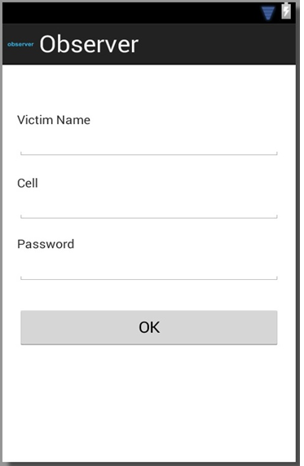

**Fig 10.6 Device ringing acknowledgement**

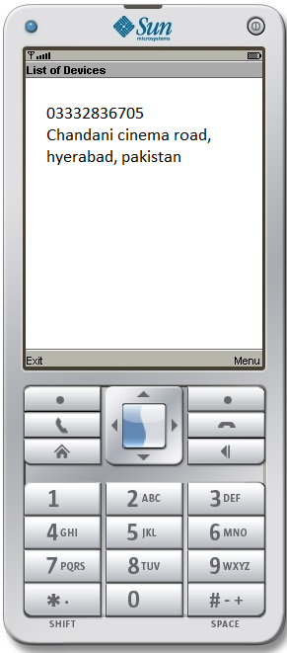

**Fig 10.6 Device Ringing**

**Fig 10.6 GPS location detail acknowledgement**

## 10.2 BIBLIOGRAPHY

References:

1. Hello Android, the Pragmatic Programmers (2009),E. Burnette.
2. Professional Android 2 Application Development, R. Meier, Wiley (2010).
3. Beginning Android 2, M. Murphy, Apress (2010).
4. Android Developer Guide: <http://developer.android.com/guide/index.html>.
5. Android API: <http://developer.android.com/reference/packages.html>
6. V-Model:<http://en.wikibooks.org/wiki/Introduction_to_Software_Engineering/Process/V-Model>